


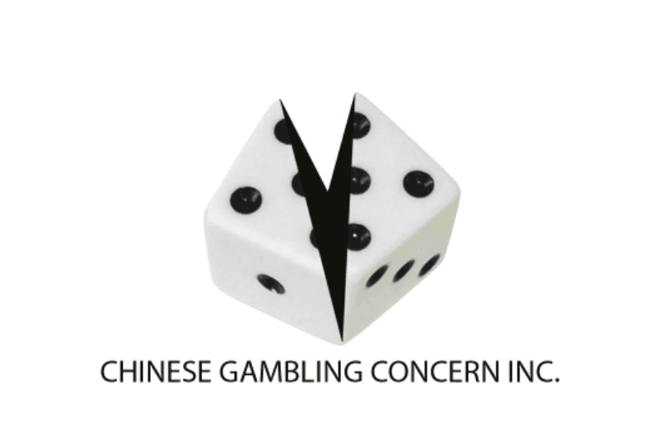
Chocolate Making Fun Day (June 24, 2017)
手工巧克力制作
Chinese Gambling Concern Incorporated
华人赌博关怀协会主办
Registration Form 申请表
Participant 参加者
Chinese Name姓名:
Gender性别: F / M
Age年龄:
Mobile电话（必填）:
Email邮件:
Address家庭住址:
Note注意: Please return this form to Chinese Gambling Concern Inc. 请把报名表提交到华人赌博关怀协会。
通过以下方式：
- Return this form to our office提交到办公室: Suite 16, 27 Bank Street, Box Hill Town Hall, Box Hill, Vic 3128
- Return this form to our email提交到邮件: Enquiry@cgci.org.au
- Return this form to our We chat 提交到微信: CGCI_VIC
Emergency Contact 紧急联系人:
Full Name 姓名 :
Mobile 电话:
Relationship to participant 与参与者关系：

Medical Condition: (Please indicate any specific medical conditions such as heart dieses the organizer should be aware of and agreed to authorise Chinese Gambling Concern Inc. to obtain medical assistance as they see fit and will meet all expenses thereof.)
医疗状况:(请注明参与者注明的个人特殊身体状况，如心脏病或其他伤患等；并同意授权华人赌博关怀协会在必要时安排合适的医疗援助，所产生的医疗费用由参与者自行承担。)

Signature 签名: Date 日期:

