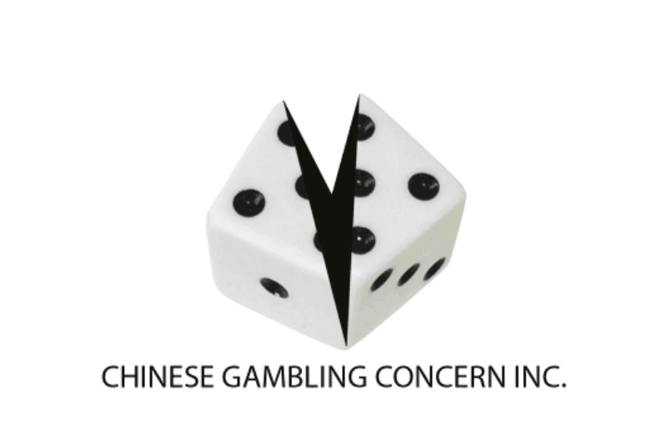

Free Bubble Soccer Fun Day for Chinese Overseas Students
Date of Event: Saturday, 12 March 2016
Venue: Box Hill Indoor Sports, 9 Clarice Rd, Box Hill
Organiser: Chinese Gambling Concern Incorporated
Registration Form
Pls. circle a time to join: 4.15pm to 5.15pm
Family Name: First Name:
Chinese Name:
Gender: F / M (please circle) Age:
Address:
Mobile: Home:
Email:
Name of University/TAFE/School attending:
Year/Level/Grade:

Signature: Date:
Note: A registration fee of $10 per person is required in submitting this form, but this amount will be refunded on the day of event only after attending this activity. Pls return this form to Chinese Gambling Concern Inc., Suite 16, 27 Bank Street, Box Hill Town Hall, Box Hill, Vic 3128
Payment Method:
1. Cash / Cheque (Payable to Chinese Gambling Concern Inc. Pls enclose it in this form)/
2. Direct Deposit (Bendigo Bank, BSB: 633 108 A/C 1503 52300. Pls enclose receipt in this form)
Total amount: AUD$ _______________

Emergency Contact:
Family Name: First Name:
Mobile: Home: Business:
Relationship to participant: ________________________

Medical Condition: (Pls indicate any specific medical conditions, such as heart disease, injury that the organizer should be aware of, and you authorise Chinese Gambling Concern Inc. to obtain medical assistance as they see fit and will meet all expenses thereof.)
My special medical condition: Nil OR specify:______________________________________________
I, _____________________, authorize Chinese Gambling Concern Inc to obtain medical assistance as they see fit and will meet all expenses thereof.

Signature: Date:

