***海外華人留學生 免費泡泡足球同樂日***



***維省華人賭博關懷協會***誠意邀請海外華人留學生參與我們舉辦的健康活動，和認識更多新朋友，讓彼此在一個悠閒的週六下午，齊齊嚐試一下近期流行的泡泡足球。

日期：2016年3月12日（星期六）

時間：下午4:15至 5:15

參加者：海外華人留學生 (說普通話及粵語) *本地大學生只要攜同海外華人留學生朋

友便可一起參加。

參加地址：博士山室內運動館

(Box Hill Indoor Sports, 3/9 Clarice Rd., Box Hill South, VIC 3128)

詳情：每組分2隊同埸進行比賽，每人都會穿上巨型泡泡足球，大家可以施展渾身解數，碰碰撞撞，務求把球射進龍門。

費用：免費（每位參加者需於報名時交**$10**登記費，但費用會於出席活動當天退還，如沒有出席者，登記費則恕不退還）  
報名方法：  
1. 從www.cgci.org.au下載報名表  
2. 郵寄索取：Suite 16,，27 Bank Street，Box Hill Town Hall, Box Hill, 3128 (請附回

郵信封)

3. 親身索取：Suite 16，27 Bank Street，Box Hill Town Hall, Box Hill, 3128   
**名額有限，先到先得!** 截止報名日期: 12月4日。查詢電話：92756988，或電郵: enquiry@cgci.org.au

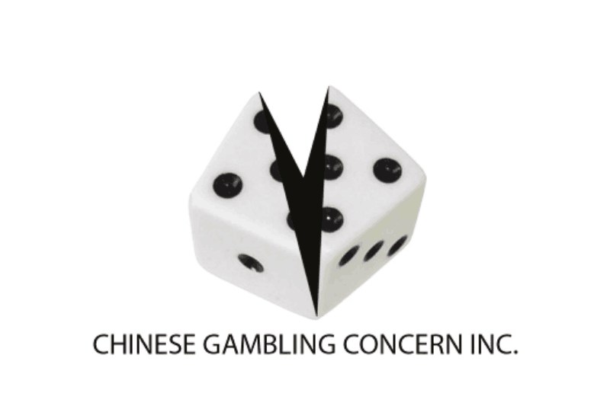本活動由***維多利亞省負責任賭博基金會***資助。



***Chinese International Students FREE Bubble Soccer Fun Day***



***Chinese Gambling Concern Inc.(CGCI)*** invites all Chinese international students to a healthy sporting event! You can meet more friends and network. Join us and have fun together with the popular Bubble Soccer on a relaxing Saturday afternoon!

Date: Sat, 12 Mar 2016

Time: 4:15pm to 5:15pm

Participants: Chinese International Student (Mandarin & Cantonese speaking)

* Local Chinese student may join if you bring friends who are international students

Venue: Box Hill Indoor Sports

(Box Hill Indoor Sports, 3/9 Clarice Rd., Box Hill South, VIC 3128)

Details：Game is played between team of 5, carrying a giant bubble. Hard tackling is not only allowed but encouraged. Your martial skills can be an advantage! Go and score for your team!

Cost：Free (A registration fee of $10 is required to confirm admission and will be fully refunded **ONLY** upon attendance on the day.）   
Registration form:  
1. Download via [www.cgci.org.au](http://www.cgci.org.au).  
2. Request via post：Suite 16, 27 Bank Street，Box Hill Town Hall, Box Hill, 3128

(Please enclose with a return envelope)

3. In-person：Suite 16, 27 Bank Street，Box Hill Town Hall, Box Hill, 3128

Limited spaces, first come first in!

Registration close: 4 Dec 2015 Inquiry: 92756988; OR email: enquiry@cgci.org.au

CGCI is a non-profit organization

This event is funded by ***Victorian Responsible Gambling Foundation***.



